**MySQL string [17 exercises with solution]**

1. Write a [MySQL](https://www.w3resource.com/mysql-exercises/string-exercises/) query to get the job_id and related employee's id.  
   Partial output of the query :

|  |  |
| --- | --- |
| job_id | Employees ID |
| AC_ACCOUNT | 206 |
| AC_MGR | 205 |
| AD_ASST | 200 |

[SELECT](http://localhost/phpmyadmin/url.php?url=https://dev.mysql.com/doc/refman/8.0/en/select.html) JOB_ID,[GROUP_CONCAT](http://localhost/phpmyadmin/url.php?url=https://dev.mysql.com/doc/refman/8.0/en/aggregate-functions.html%23function_group_concat)(employee_id, ' ') AS 'Employees ID' FROM employees GROUP BY JOB_ID;

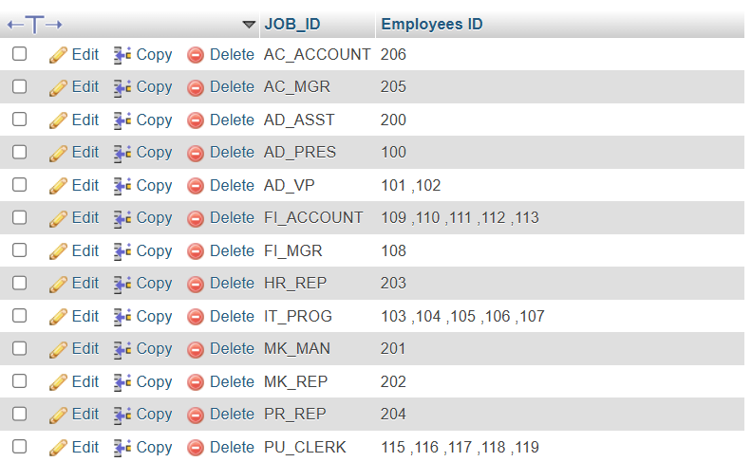

1. Write a [MySQL](https://www.w3resource.com/mysql-exercises/string-exercises/) query to update the portion of the phone_number in the employees table, within the phone number the substring '124' will be replaced by '999'.

[UPDATE](http://localhost/phpmyadmin/url.php?url=https://dev.mysql.com/doc/refman/8.0/en/update.html) employees [SET](http://localhost/phpmyadmin/url.php?url=https://dev.mysql.com/doc/refman/8.0/en/set.html) phone_number = [REPLACE](http://localhost/phpmyadmin/url.php?url=https://dev.mysql.com/doc/refman/8.0/en/replace.html)(phone_number, '124', '999') WHERE phone_number [LIKE](http://localhost/phpmyadmin/url.php?url=https://dev.mysql.com/doc/refman/8.0/en/string-comparison-functions.html%23operator_like) '%124%';

[SELECT](http://localhost/phpmyadmin/url.php?url=https://dev.mysql.com/doc/refman/8.0/en/select.html) * FROM employees WHERE phone_number [LIKE](http://localhost/phpmyadmin/url.php?url=https://dev.mysql.com/doc/refman/8.0/en/string-comparison-functions.html%23operator_like) '%123%';

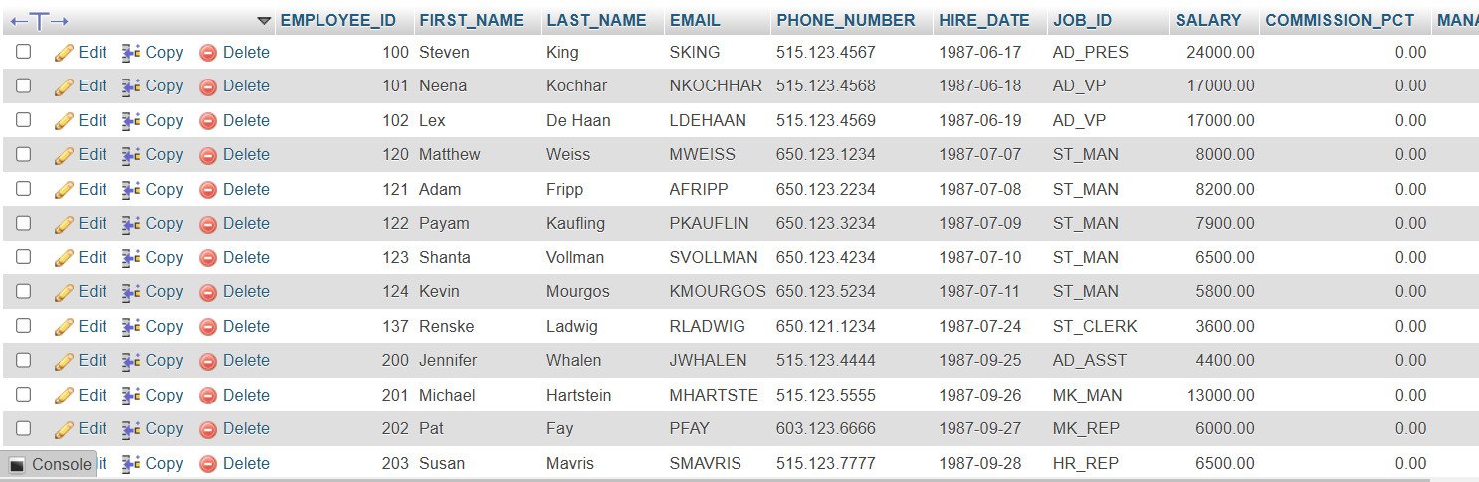

1. Write a [MySQL](https://www.w3resource.com/mysql-exercises/string-exercises/) query to get the details of the employees where the length of the first name greater than or equal to 8.

[SELECT](http://localhost/phpmyadmin/url.php?url=https://dev.mysql.com/doc/refman/8.0/en/select.html) * FROM employees WHERE LENGTH(FIRST_NAME) >= 8;

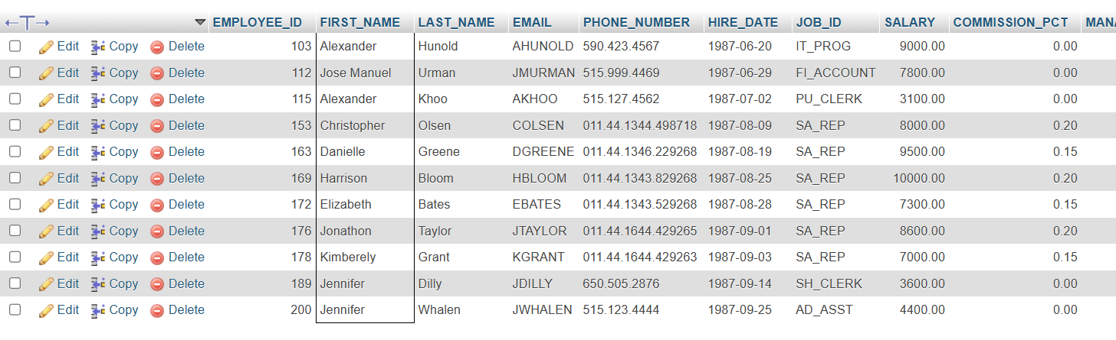

1. Write a [MySQL](https://www.w3resource.com/mysql-exercises/string-exercises/) query to display leading zeros before maximum and minimum salary.

[SELECT](http://localhost/phpmyadmin/url.php?url=https://dev.mysql.com/doc/refman/8.0/en/select.html) JOB_ID, LPAD(MAX_SALARY, 7, '0') AS ' Max Salary', LPAD(MIN_SALARY, 7, '0') AS ' Min Salary' FROM jobs;

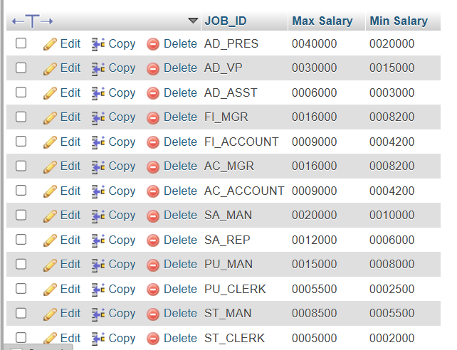

1. Write a MySQL query to append '@example.com' to email field.

[UPDATE](http://localhost/phpmyadmin/url.php?url=https://dev.mysql.com/doc/refman/8.0/en/update.html) employees [SET](http://localhost/phpmyadmin/url.php?url=https://dev.mysql.com/doc/refman/8.0/en/set.html) EMAIL = CONCAT(EMAIL, '@example.com');

[SELECT](http://localhost/phpmyadmin/url.php?url=https://dev.mysql.com/doc/refman/8.0/en/select.html) EMAIL FROM employees;

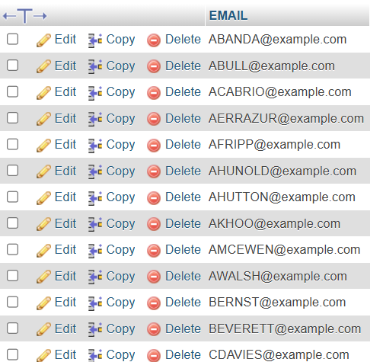

1. Write a [MySQL](https://www.w3resource.com/mysql-exercises/string-exercises/) query to get the employee id, first name and hire month.

[SELECT](http://localhost/phpmyadmin/url.php?url=https://dev.mysql.com/doc/refman/8.0/en/select.html) EMPLOYEE_ID,FIRST_NAME,MID(hire_date, 6, 2) as hire_month FROM employees;

**7.** Write a [MySQL](https://www.w3resource.com/mysql-exercises/string-exercises/) query to get the employee id, email id (discard the last three characters).

**Sample table: employees**

[SELECT](http://localhost/phpmyadmin/url.php?url=https://dev.mysql.com/doc/refman/8.0/en/select.html) EMPLOYEE_ID, REVERSE(SUBSTR(REVERSE(EMAIL), 4)) as Email_ID FROM employees;

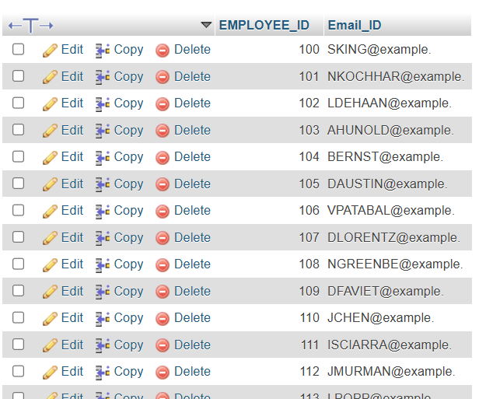

1. Write a [MySQL](https://www.w3resource.com/mysql-exercises/string-exercises/) query to find all employees where first names are in upper case.

[SELECT](http://localhost/phpmyadmin/url.php?url=https://dev.mysql.com/doc/refman/8.0/en/select.html) * FROM employees WHERE FIRST_NAME = [BINARY](http://localhost/phpmyadmin/url.php?url=https://dev.mysql.com/doc/refman/8.0/en/cast-functions.html%23operator_binary) UPPER(FIRST_NAME);



1. Write a [MySQL](https://www.w3resource.com/mysql-exercises/string-exercises/) query to extract the last 4 character of phone numbers.

[SELECT](http://localhost/phpmyadmin/url.php?url=https://dev.mysql.com/doc/refman/8.0/en/select.html) [RIGHT](http://localhost/phpmyadmin/url.php?url=https://dev.mysql.com/doc/refman/8.0/en/string-functions.html%23function_right)(PHONE_NUMBER, 4) as 'Ph.No.' FROM employees;

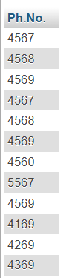

1. Write a [MySQL](https://www.w3resource.com/mysql-exercises/string-exercises/) query to get the last word of the street address.

[SELECT](http://localhost/phpmyadmin/url.php?url=https://dev.mysql.com/doc/refman/8.0/en/select.html) LOCATION_ID, STREET_ADDRESS, SUBSTRING_INDEX( [REPLACE](http://localhost/phpmyadmin/url.php?url=https://dev.mysql.com/doc/refman/8.0/en/replace.html)( [REPLACE](http://localhost/phpmyadmin/url.php?url=https://dev.mysql.com/doc/refman/8.0/en/replace.html)( [REPLACE](http://localhost/phpmyadmin/url.php?url=https://dev.mysql.com/doc/refman/8.0/en/replace.html)(STREET_ADDRESS,',',' '), ')',' '), '(',' '), ' ',-1) AS 'Last--word-of-street_address' FROM locations;

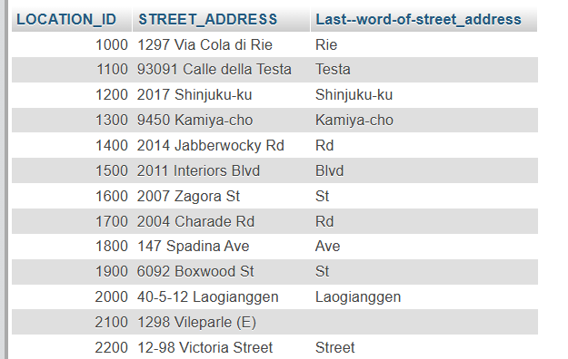

1. Write a MySQL query to get the locations that have minimum street length.

[SELECT](http://localhost/phpmyadmin/url.php?url=https://dev.mysql.com/doc/refman/8.0/en/select.html) * FROM locations WHERE LENGTH(STREET_ADDRESS) <= ( [SELECT](http://localhost/phpmyadmin/url.php?url=https://dev.mysql.com/doc/refman/8.0/en/select.html) [MIN](http://localhost/phpmyadmin/url.php?url=https://dev.mysql.com/doc/refman/8.0/en/aggregate-functions.html%23function_min)(LENGTH(STREET_ADDRESS)) FROM locations );

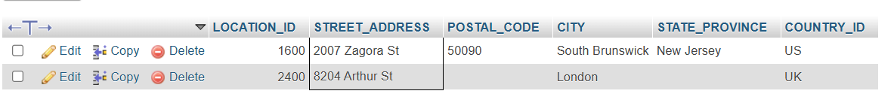

1. Write a MySQL query to display the first word from those job titles which contains more than one words.

[SELECT](http://localhost/phpmyadmin/url.php?url=https://dev.mysql.com/doc/refman/8.0/en/select.html) JOB_TITLE, SUBSTR(JOB_TITLE, 1, INSTR(JOB_TITLE, ' ') - 1) FROM jobs;

[SELECT](http://localhost/phpmyadmin/url.php?url=https://dev.mysql.com/doc/refman/8.0/en/select.html) JOB_TITLE, SUBSTR(JOB_TITLE, 1, INSTR(JOB_TITLE, ' ') - 1) AS 'Job Title' FROM jobs;

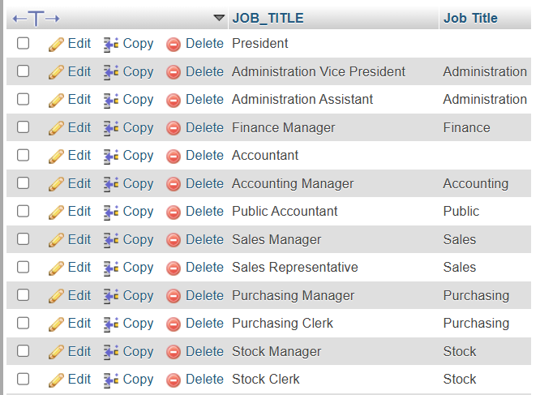

1. Write a MySQL query to display the first name and last name for employees where first occurrence of last name contain character 'c' after 2nd position.

[SELECT](http://localhost/phpmyadmin/url.php?url=https://dev.mysql.com/doc/refman/8.0/en/select.html) FIRST_NAME, LAST_NAME FROM employees WHERE INSTR(LAST_NAME,'C') > 2;

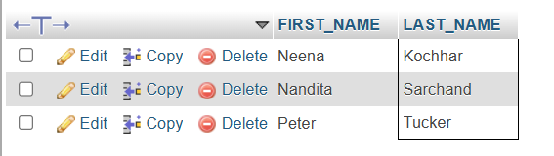

1. Write a [MySQL](https://www.w3resource.com/mysql-exercises/string-exercises/) query that displays the first name and the length of the first name for all employees whose name starts with the letters 'A', 'J' or 'M'. Give each column an appropriate label. Sort the results by the employees' first names.

[SELECT](http://localhost/phpmyadmin/url.php?url=https://dev.mysql.com/doc/refman/8.0/en/select.html) FIRST_NAME "Name", LENGTH(FIRST_NAME) "Length" FROM employees WHERE FIRST_NAME [LIKE](http://localhost/phpmyadmin/url.php?url=https://dev.mysql.com/doc/refman/8.0/en/string-comparison-functions.html%23operator_like) 'J%' [OR](http://localhost/phpmyadmin/url.php?url=https://dev.mysql.com/doc/refman/8.0/en/logical-operators.html%23operator_or) FIRST_NAME [LIKE](http://localhost/phpmyadmin/url.php?url=https://dev.mysql.com/doc/refman/8.0/en/string-comparison-functions.html%23operator_like) 'M%' [OR](http://localhost/phpmyadmin/url.php?url=https://dev.mysql.com/doc/refman/8.0/en/logical-operators.html%23operator_or) FIRST_NAME [LIKE](http://localhost/phpmyadmin/url.php?url=https://dev.mysql.com/doc/refman/8.0/en/string-comparison-functions.html%23operator_like) 'A%' ORDER BY FIRST_NAME;

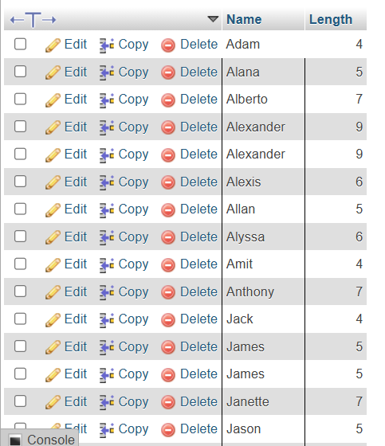

1. Write a [MySQL](https://www.w3resource.com/mysql-exercises/string-exercises/) query to display the first name and salary for all employees. Format the salary to be 10 characters long, left-padded with the $ symbol. Label the column SALARY.

[SELECT](http://localhost/phpmyadmin/url.php?url=https://dev.mysql.com/doc/refman/8.0/en/select.html) FIRST_NAME, LPAD(SALARY, 10, '$') SALARY FROM employees;

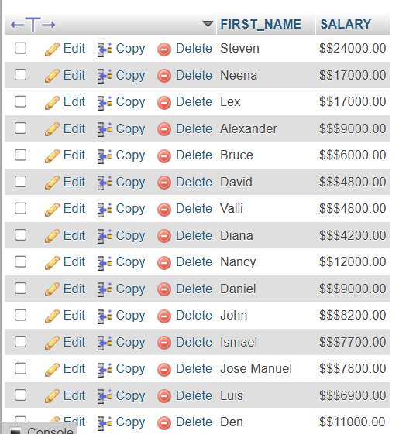

1. Write a [MySQL](https://www.w3resource.com/mysql-exercises/string-exercises/) query to display the first eight characters of the employees' first names and indicates the amounts of their salaries with '$' sign. Each '$' sign signifies a thousand dollars. Sort the data in descending order of salary.

[SELECT](http://localhost/phpmyadmin/url.php?url=https://dev.mysql.com/doc/refman/8.0/en/select.html) [LEFT](http://localhost/phpmyadmin/url.php?url=https://dev.mysql.com/doc/refman/8.0/en/string-functions.html%23function_left)(FIRST_NAME, 8), [REPEAT](http://localhost/phpmyadmin/url.php?url=https://dev.mysql.com/doc/refman/8.0/en/string-functions.html%23function_repeat)('$', FLOOR(SALARY/1000)) 'SALARY($)', SALARY FROM employees ORDER BY SALARY DESC;

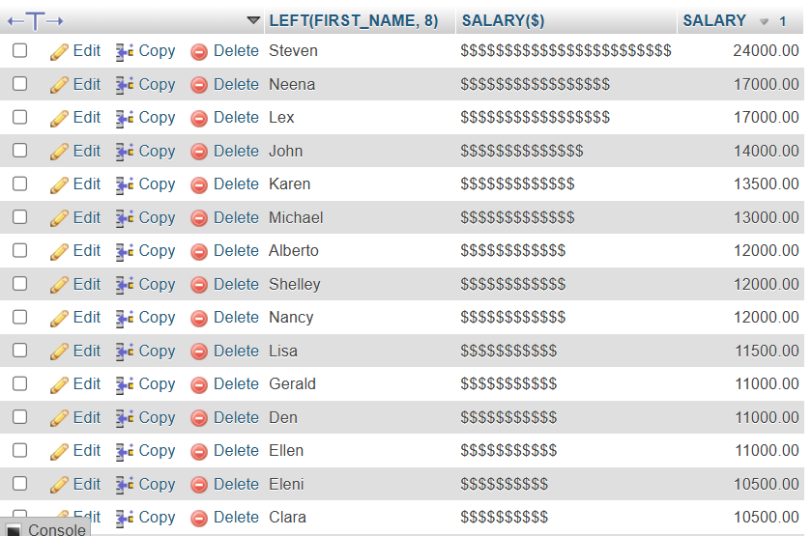

1. Write a [MySQL](https://www.w3resource.com/mysql-exercises/string-exercises/) query to display the employees with their code, first name, last name and hire date who hired either on seventh day of any month or seventh month in any year.

[SELECT](http://localhost/phpmyadmin/url.php?url=https://dev.mysql.com/doc/refman/8.0/en/select.html) EMPLOYEE_ID, FIRST_NAME, LAST_NAME, HIRE_DATE FROM employees WHERE POSITION("07" [IN](http://localhost/phpmyadmin/url.php?url=https://dev.mysql.com/doc/refman/8.0/en/comparison-operators.html%23function_in) DATE_FORMAT(HIRE_DATE, '%d %m %Y')) > 0;

